Name:
Class:
Age Structure and Populations
Age structure diagrams are valuable tools that demographers use to look into the past of a population and predict the future growth rate and needs of that population. It uses percentages of males and females of different ages in a population to determine if the population is steady, growing or shrinking. Use the data provided to calculate the percentages of each cohort age group and create an age structure diagram for the country you are assigned.

Calculate percentages: number is/of possible x 100= %

Male Female Age
75+
70-74
65-69
60-64
55-59
50-54
45-49
40-44
35-39
30-34
25-29
20-24
15-19
10-14
5-9
0-4
8 6 4 2 0 2 4 6 8
Percent of Population

My country is:_____________________________ found in the region of:_________________________________
It is a wealthy (developed) country or a poorer (developing) country:_________________________
The shape of my age-structure diagram is:_________________________ meaning my country is growing/shrinking or stable (circle one).

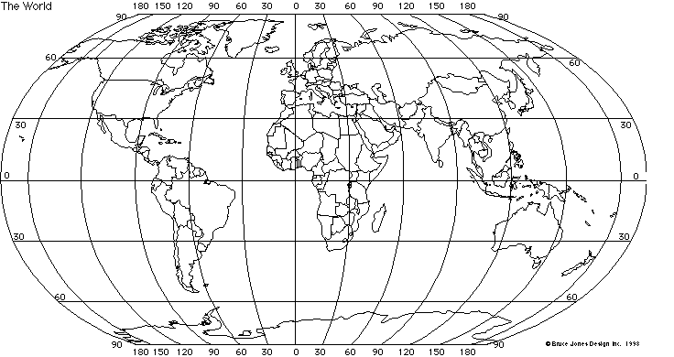

Color the location of your country on the map.

Follow Up Questions
- Where would YOU be on the population pyramid if you lived in this country?

- Which age group is most abundant in your country graph; the pre-reproductive (0-20), reproductive (20’s-40”s) or post-reproductive (50’s and up)? What does that say about the growth of your population? (Is this good or bad for you?).

- What is the number of births per female to maintain a steady population size? For the population to grow? For the population to shrink?

- What factors slow the growth rate of human populations?

- Are there more male or female babies born in each of the countries or is it about even?

- Are there more elderly males or females? What might be the cause of this difference?

- Which country graphs looks most like a pyramid? What does that say about their population growth rate? What needs would that country have in the future?

- From the population graphs, which country appears to have the slowest growth? What will be the needs of that country in the future?

- Predict what the pyramid of Mexico will look like in the future given its current population. What does that tell you about how the birth rate has changed in Mexico?

- If you had a business, what products would sell best in Nigeria and why (using the population information)? What products would sell best in the USA and why?

