Accretion Theory

A: What do you see in the 3 pictures? What is happening? How is this happening?

5-6 Billion years ago
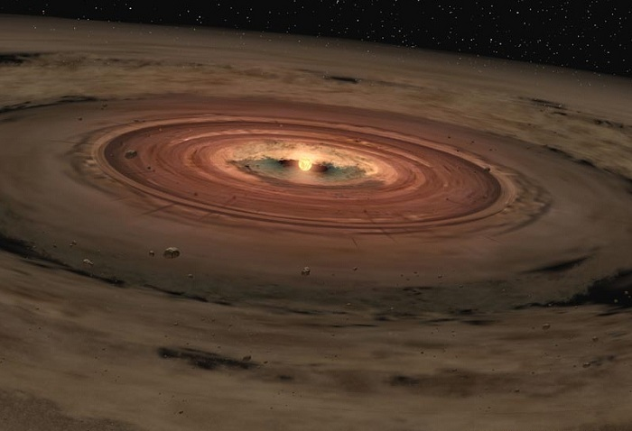
Write down your thinking –

5 Billion years ago
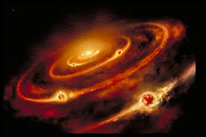

Today
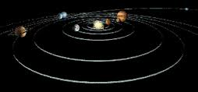

B. Talking Sticks Protocol:
Each person places his or her pencil/pen as a “talking stick” in the center of the group.
- Take turns making a single comment about the series of pictures by picking up your “talking stick” and making your comment while you hold it. No one is allowed to interupt you or speak out of turn.
- Once you are finished with your comment, set your “talking stick” in front of you and you are not allowed to comment again until all the other group memebers have had a turn (no member is allowed to pass!).
- After everyone in the group has had a chance to comment, repeat the process a second time.
- Edit your explanation based on the talking sticks ideas.

3. Paragraph Summary:
- Each person reads the first paragraph silently and looks up when done waiting for the others.
- The group discusses the content of the paragraph to come to consensus about main ideas.
- After agreeing how to write the 2-3 main ideas, each person records them in their notebook silently.
- Repeat steps 1-3 for each paragraph of the reading.

Paragraph 1:
The sun and planets of our solar system started as a huge nebula cloud of tiny gas and dust particles. Dust grains would randomly collide and stick or accrete into larger clumps but this increase in mass came with it an increase in gravity. The bigger clump with more gravitational pull would attract more material resulting in faster and faster clumping into meteor sized particles and then asteroid sized particles. This ever increasing build up of material to form the solar system is called the accretion theory and is evidenced by crater marks on planets and moons without the smoothing effects of water and wind.

Paragraph 2:
As the material pulled inward the entire cloud began to spin much like an ice skater that pulls in their arms begins to spin faster. This spinning motion whipped out and flattened the nebula into a disc shape. Thousands of swirling asteroids gathered the material closest to it creating empty rings within the cloud that would eventually become the orbital paths of hundreds of moon sized particles called planetesimals (or dwarf planets). Studies suggest that larger planetesimals were fewer in number but continued to pull each other out of orbit and merge to form planets in an even more dramatic fashion. As they collided, fragments of debris would spray into the space around the collision area and either rain back to the newly formed planet or if farther out, form a moon as it gathered into a separate revolving clump. Our moon is heavier on one side suggesting it formed as a larger planetesimal sheered off a large amount of debris from the forming earth. Planets are considered fully formed when all of the material in their orbital path has clumped into one orbiting mass. Pluto has been demoted to planetesimal status as multiple large objects are still in it’s path and yet to be accreted.

Paragraph 3:
The largest clump in the center became our sun. Like the planets, massive pressure on the core produced frictional heat causing them to glow like volcanic lava. Eventually the mass was so heavy that gravity pulled the small atoms within the core into each other, merging them into larger atoms. The merger of atoms is a nuclear reaction called fusion resulting in an immense explosion of radiant energy. This is when the sun begins to produce the light that we are familiar with from a shining sun. The close forming planets of Mercury, Venus, Earth and Mars were blasted with the sun’s energy, stripping them of any light gases that had yet to clump. These closer inner planets are called the terrestrial or rocky planets because they are mostly made of more dense silicate minerals, are small and have little to no atmospheres. Volcanic gases and released gases from colliding comets allowed our planet to replace our lost atmosphere and form the oceans after this solar blast.

Paragraph 4:
As the sun blasted these gases into the outer regions of the solar system they began to cool and freeze into solid ices. The planetesimals that became Jupiter, Saturn, Uranus and Neptune were far enough from the sun’s blazing heat, to grab the passing gases and hang onto them. The outer planets or Jovian planets as they are all called are all low density, gas giants with several moons as a result. They also have thick atmopheres and several moons due to the extra gas and dust materials.

Paragraph 5:
Between the inner and outer planets lies the asteroid belt, a region of large clumps that never made it all the way to "planet-hood." Why are most asteroids stranded in the zone between Mars and Jupiter? This is probably because that was the planet-forming zone closest to Jupiter, the largest planet in the Solar System. Most fragments in the region would clump to Jupiter as it had the strongest gravity nearby. But some fragments were left stranded in between with not enough gravity to pull them into either region. Fragments are stilled pulled out of the asteroid belt and become meteorites that land on planets and continue the accretion process of planet formation.

