Name:

Class:

**Far Side Observations & Inferences**

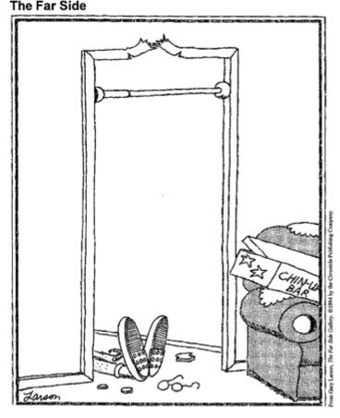1. Write a detailed account of what happened in the cartoon. You must fill the entire space below.

2. Read the definitions of observation and inference:

* **Observation** is the act of seeing an object or event and noting the physical characteristics or points in the event. Observation is an extension of our senses; when we observe, we record what is seen , smelled, tasted, heard and touched.
* **Inferences** are conclusions based on observations. Inferences go beyond what we can directly sense.

Re-read your account above and underline all of your statements that were observations once. Any statements that are inferences underline them twice.

3. Read the definitions of qualitative and quantitative observations.

* **Qualitative** observations describe an object’s characteristics, properties or attributes. For example in the statement, the “The apple is round and red”, both round and red describe the apple’s appearance.
* **Quantitative** observations involve a n amount or quantity. In the statement, “the apple weighs 138 grams”, 138 grams is a quantitative observation of the apple’s appearance.

Re-read the account you wrote. In the margin, mark all of the qualitative observations you wrote with the label for adjective (adj) and mark all the quantitative observations with the pound sign (#). If you didn’t make any quantitative observations go back and add some.

4. Making observations is not as straightforward as you might think. The mind interprets what we sense very quickly. For the following statements, mark an “O” for the observations and an “I” for the inferences.

1. _____ The time of day in the cartoon is unknown.
2. _____ The person is wearing shoes and socks.
3. _____ The person pictured is a man.
4. _____ The chin-up bar is set too high.
5. _____ The chin-up bar arrived in one package.
6. _____ The person pictured has less than perfect 20/20 eyesight.
7. _____ The person is lying on the their back.
8. _____ The person has sustained an injury.
9. _____ The person is a teenager.
10. _____ The frame of the glasses is bent.
11. _____ This was the first time the individual used a chin-up bar.

5. Scientists make inferences as they attempt to develop answers to questions about what they observe. Write three inferences to explain why the person is lying on the ground. For each inference provide one piece of supporting evidence.

* Inference:

Evidence:

* Inference:

Evidence:

* Inference:

Evidence:

6. Indicate which inference is most plausible by marking a star next to it. Based on the cartoon, write a scientific research question that could be answered with an experiment.