Model of the Solar System

Big Question
How did we come to our current understanding of the solar system?
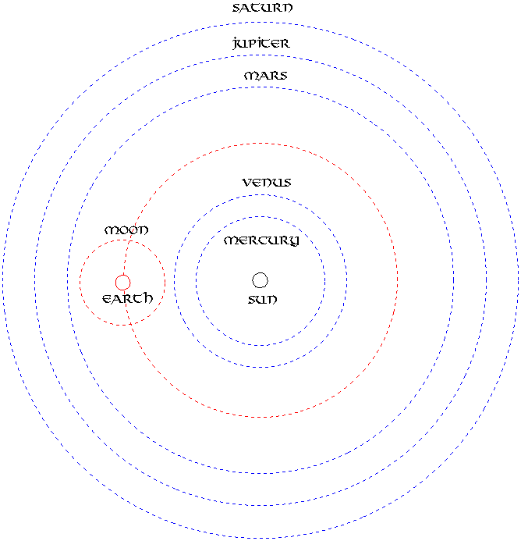
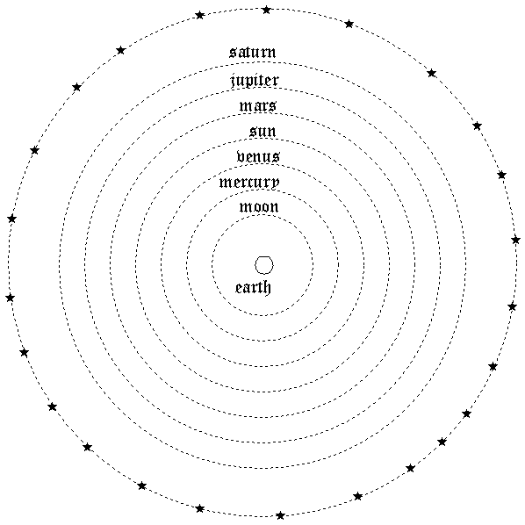

Model 1 (Printed in 1568) Model 2 (Printed in 1543)

Activity
- Look at the two models. Silently record all the differences you observe between the two models.
- As a group, share your observations. Add any observations others had that you didn’t
My Observations | New Observations from Partners

- Choose 2 or 3 of your observations to turn into questions. Record each question below and then on a piece of paper to tape on the white board.
- Talking Sticks. Which of the two models would each piece of data fit and why?
- Choose 1 person to keep the group on track.
- Read ONE piece of observational data silently and record a possible cause behind that observation (infer the cause of that observation).
- All pens are in the middle of the table.
- One person at a time may pick up their pen to explain what they think is causing that observation. When done talking they place their pen on their paper.
- Rotate until all pens have been picked up and ideas shared by all.
- Repeat with the next observation.

Observational Data
Observation | Possible inferred cause
- The Earth doesn’t feel like it is moving

- The Earth doesn’t have a constant great wind (or fast moving air in atmosphere)
- The sun rises in the East goes across the sky and sets in the West every day
- The stars “spin” or rotate a half circle every night.
- The moon goes through phases every month

- Models are designed to make sense of our observations. Match the observation with the models (if observation 1 can be explained using model 1 and 2, record “observation 1” in the both column). Discuss as a group.

Record the observation according to which model best explains the observation
Model 1 | Fits Both Models | Model 2

