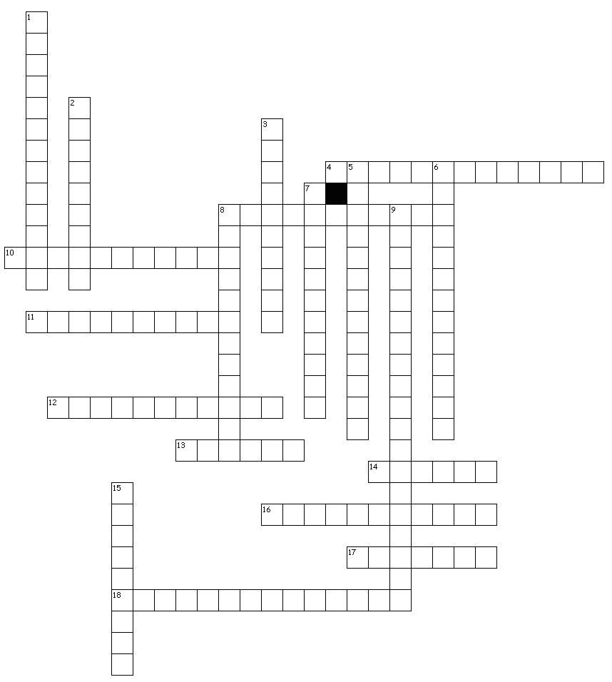
Across
Name:
Class:

Water & Carbon Cycles
4. the evaporation of water from leaf stomata; contributes to cloud creation
8. carbon moving through the biotic and abiotic parts of the ecosystem
10. when animals eat plants they consume their stored carbon
11. fossil fuels or wood are burned, releasing their stored carbon into the air
12. water heats to change from a liquid to a gas
13. water that moves along the surface and often picks up pollutants
14. all living parts of the ecosystem
16. water moves through soil to become part of the groundwater aquifer
17. all nonliving parts of the ecosystem
18. plankton, crabs, clams etc. pull carbon from water to build shells
Down
1. bacteria break down dead plants & animals, releasing stored carbon
2. volcanoes melt carbon containing rock and release CO2 to the air
3. the movement of water through the ecosystem; 100% is conserved
5. empty shells float to the bottom of the ocean to squish into rock (limestone)
6. any water that falls from the sky (rain, hail, snow…)
7. dead plants & animals are buried and compressed into coal, oil, gas etc.
8. water vapor in the air cools to become a liquid
9. sugars are burned in cells releasing energy and CO2/H20 is breathed out
15. excess CO2 dissolves into oceans from the atmosphere

