Lab Title:

Lab Design (Pre-Lab)
LAB QUESTION What testable question are you trying to answer in the investigation?

INDEPENDENT VARIABLE  What are you changing in each trial? | DEPENDENT VARIABLE  What is being measured?
HYPOTHESIS
Format: IF (IV: this is changed), THEN (DV: this will change in this way), BECAUSE (of this reason)

EXPERIMENTAL DESIGN Diagram and describe (annotate) each group in the experiment

CONSTANTS Factors held the same in all trials  Evident in your design diagrams | CONTROL(s) Lacks the IV  Trial the experimental group is compared to
II. DATA
- Draft your tables/graphs on the whiteboard before committing to your notebook
- Include examples of calculations

IV  What you modify in the lab design | DV  What you measure as your data |  | RESULTS  Differences,  Averages…

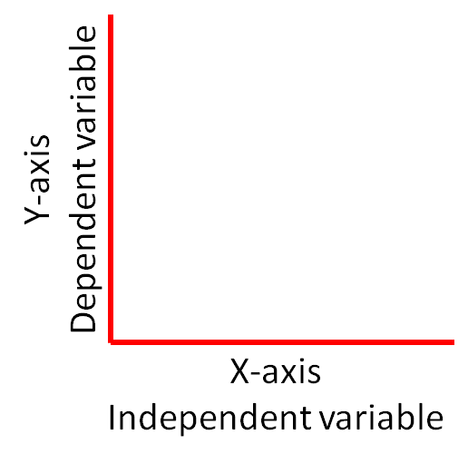
- Columns/rows/axes include variable and unit “the effect of..”
- Choose graph type based on data type: “the relationship between..”
Discreet Comparison: columns, bars
Continuous Change: point, line, histogram
- Use color, patterns, a key when needed
- Graph relationships can be positive, negative or
unrelated

III. ANALYSIS – 2 paragraphs

Claim, Evidence and Reasoning (Claim, Data, Warrant)
- Claim-Make factual claims from the patterns evident in the data, stating the relationship between the variables.
- Evidence-Cite specific data numbers or observations as evidence to support your claim.

Reasoning-Explain why that evidence supports your claim including unit concepts and vocabulary to infer the underlying cause of your lab results. You may extend that to predict the results of additional tests and applications to the real world.

Data Reflection
- Does the data support the hypothesis?

Explain two errors resulting from lab design, or any human error that went uncorrected.

Are your results conclusive (do you trust your results)? Base this claim on the number of trials, class results, effect of errors, etc.

