Lab Notebook Format

I. PRE-LAB

LAB QUESTION What testable question are you trying to answer in the investigation?

INDEPENDENT VARIABLE  What are you changing in each trial? | DEPENDENT VARIABLE  What is being measured?
HYPOTHESIS
Format: IF (IV: this is changed), THEN (DV: this result will change in this way), BECAUSE (of this reason)

EXPERIMENTAL DESIGN Diagram and describe (annotate) each group in the experiment

CONSTANTS Factors held the same in all trials  Evident in your design diagrams | CONTROL(s) Lacks any change to the IV  Trial for comparison to the experimental group/s

II. DATA
- Draft your tables/graphs on the whiteboard or in pencil before committing to your notebook
- Include examples of calculations

IV  What you modify in the lab design | DV  What you measure as your data |  | RESULTS  Differences,  Averages…

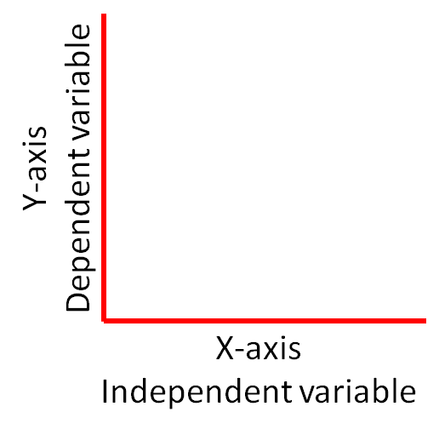
- Columns/rows/axes titled with variable and unit “The effect of..”
- Choose graph type based on data type: “The relationship between..”
Discreet Comparison: columns, bars
Continuous Change: point, line, histogram
- Use color, patterns, labeled lines when needed

III. ANALYSIS – 2 paragraphs

Claim & Evidence
- Make factual claims from the patterns evident in the data, stating the relationship between the variables.
- Cite specific data as evidence to support your claim.
- Does the data support the hypothesis?

Commentary

Use reasoning to make inferential claims from the results, including in particular the underlying cause of the effect.
- Make links to unit concepts/vocabulary. How does the lab demonstrate them?

Discuss any errors resulting from lab design, or any human error that went uncorrected.

Are your results conclusive? Base this claim on the number of trials, class results, effect of errors, etc.

