Biological Molecules
What are the building blocks of life?
Why?
From the smallest single-celled organisms to the tallest tree, all life depends on the properties and reactions of four classes of organic (carbon-based) compounds-carbohydrates, lipids, proteins and nucleic acids. These organic molecules are the building blocks of all living things, and are responsible for most of the structure and functions of the body, including energy storage, insulation, growth, repair, communication, and transfer of hereditary information. Simple organic molecules can be joined together to form all the essential organic molecules for life.

Model 1 –Organic Compounds (and their Building Blocks)
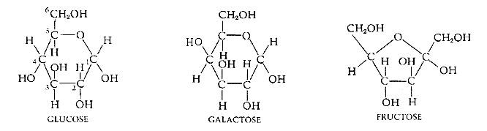
Simple Carbohydrates (Monosaccharide Monomers)
Lipids (Glycerol & Fatty Acid Monomers)

Glycerol Fatty Acids
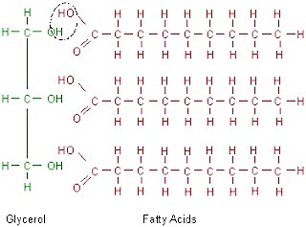
Proteins (Amino Acid Monomers)

Amino
acid
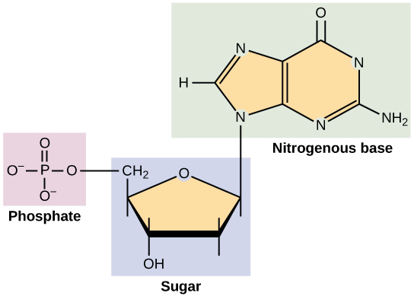
Nucleic Acids (Nucleotide Monomer)

Nucleotide

- Review Model 1. What are the four different categories of organic compounds?
- In Model 1, notice the atoms that make up each type of organic compound. List the symbol for all the atoms found in each.

- Carbohydrate:
- Lipid:
- Proteins:
- Nucleic Acids:

- Which atoms are common to ALL four classes of organic compounds; which are unique?

- How can the same few atoms be used to make so many different organic compounds?

- Which of the atoms is central (in the middle) to the structure of all four classes of organic compounds?

- The lines in a molecular diagram represent bonds between atoms. How many bonds does carbon make? How many bonds does hydrogen make?

- Use the number of bonds to infer why carbon is in the middle of organic compounds and not hydrogen.

- This central atom holds these organic compounds together. Infer the meaning of organic compound based on this observation.

- Each of the four classes of organic compounds is made by linking together a small building block molecule (monomer) into a repeating chain. What are the monomers of …

- Carbohydrate:
- Lipid:
- Proteins:
- Nucleic Acids:

- Amino Acids that make up proteins have four main parts. What are the four fundamental structure groups that make up an amino acid? Which of these is common in all amino acids? Which is unique?

- There are 20 naturally-occurring kinds of amino acid monomers, and each one only varies in the structure of the R side chain. What is the R side chain of the amino acid Alanine?

- What are the three sub-parts of the nucleotide monomer?

- What are some similarities between all four types of organic compounds? List as many as your group can think of.

Read This!
These drawings show the shape of the molecule and are called structural formulas. Each line between atoms represents a bond between them. Double bonds exist which would be represented by two lines (=). The diagrams are sometimes simplified by leaving out the central carbon symbol instead showing only the outer atoms and bonds (this can be seen in the two versions of a nucleotide).

- The number of bonds is related to the amount of energy stored in a molecule. Using this information, would carbohydrates or lipids (fats) be a better energy storage molecule? Why?

Model 2 –The Building of Complex Carbohydrates (Polysaccharides)
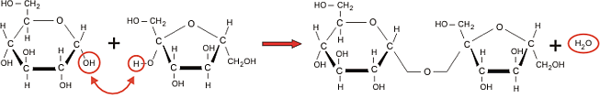
Glucose Fructose Sucrose
Polysaccharides:
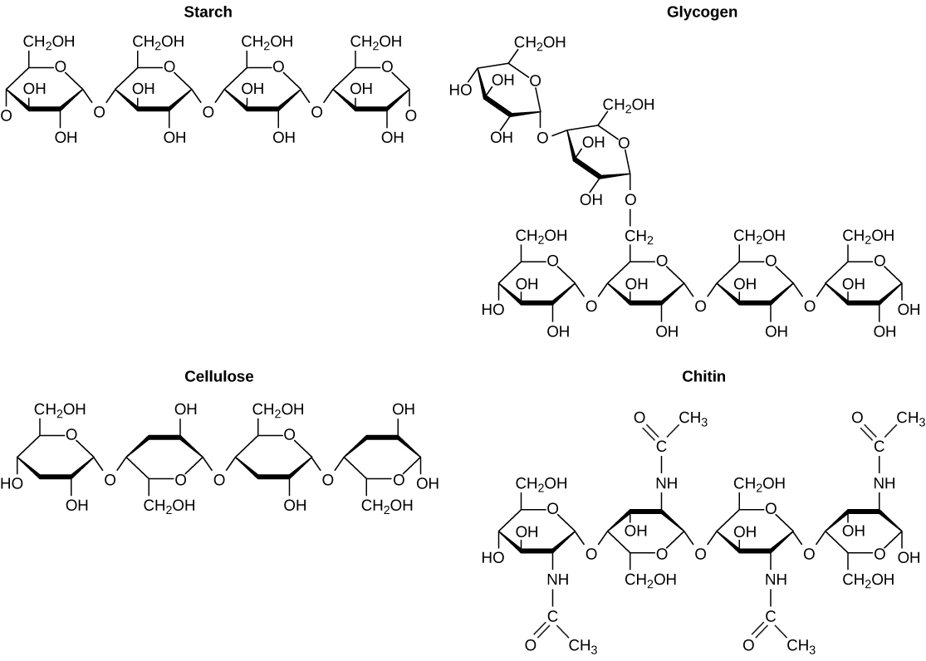

- Model 2 is demonstrating how monomers can be linked in a reaction called dehydration synthesis. What two monomers is sucrose, table sugar, (a disaccharide) made of?

- The monomers that make up sucrose are both monosaccharides while starch, glycogen, cellulose and chitin are polysaccharides. In your group decide suggest the meanings of the prefixes mono-, di- and poly-.

- All the polysaccharides in Model 2 are made of glucose (or for chitin a modified version of glucose). Starch is a digestible energy storage molecule and cellulose is a non-digestible molecule that makes up the fiber in wood and plant cell walls. How are the glucose monomers arranged differently to create the two molecules?

- Both for energy storage; starch is found in plants and glycogen in animals. How are the glucose monomers arranged differently to create the two storage molecules?

Model 3 Lipids (Saturated & Unsaturated)

- Using Model 3; What is the structural difference between a saturated and unsaturated fat?

- Infer what atom the carbons are ‘saturated’ in? What is different about the carbon atoms that allow them to be unsaturated?

- What is the difference between a monounsaturated and a polyunsaturated fat?

- Saturated fats are solid, like the animal fats of lard and butter, whereas unsaturated fats are fluid oils, like vegetables oil from plants. Trans fats are plant oils that are artificially solidified to make them suitable for storage. In recent years trans fats have been associated with negative health issues. Explain in simple molecular terms what would have to be done to a plant oil to transform it into a trans fat.

Model 4 Metabolism
Hydrolysis Reactions

H₂O
Maltose
Glucose
Glucose
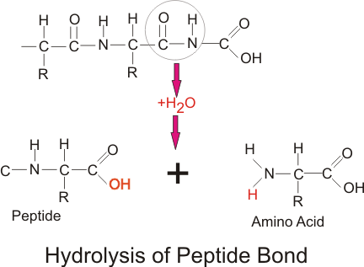

Hydrolysis of a Protein Peptide bond Hydrolysis of Maltose into Glucose

- The hydrolysis of maltose (a disaccharide) into glucose monomers (monosaccharides) is shown in Model 4. Describe what is happening to the maltose molecule. What small molecule is added in this process?

- Hydro refers to water, infer the meaning of the term hydrolysis given what you see happening to maltose.

- The making of sucrose in Model 2 is called a dehydration synthesis reaction. How is the hydrolysis reaction in Model 4 opposite of how sucrose was made?

- How is dehydration synthesis a good name for the making of polymer chain molecules?

- Bread, pasta and crackers are made of starches or other complex carbohydrates. You have a digestive enzyme called amylase that breaks down starches into simple carbohydrates. Why might starchy crackers taste sweet if let to sit on your tongue before swallowing?

- Metabolism is the collective term used to describe all the chemical reactions taking place inside living organisms. Why is water so important for metabolic reactions?

Model 1 –Organic Compounds (Building Blocks)
Simple Carbohydrates (Monosaccharide Monomers)
Lipids (Glycerol & Fatty Acid monomers)

Glycerol Fatty Acids
Proteins (Amino Acid Monomers)

Amino
acid
Nucleic Acids (Nucleotide Monomer)

Nucleotide

Model 3 Lipids (Saturated & Unsaturated)

Model 2 –Complex Carbohydrates (polysaccharides)
Glucose Fructose Sucrose
Polysaccharides:

Model 4 Metabolism
Hydrolysis Reactions

H₂O
Maltose
Glucose
Glucose

Hydrolysis of a Protein Peptide bond Hydrolysis of Maltose into Glucose

