Retrograde Motion
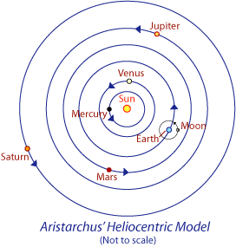
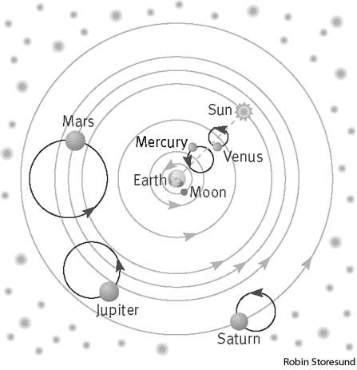
Figure 1
Epicycle

Heliocentric Model
proposed by Copernicus
Geocentric Model
proposed by Ptolemy

Looking at the two models in Figure 1….
- Centric means central or middle. What is at the center of the geocentric model? What is at the center of the heliocentric model?

- Who suggested each of these models of the solar system? Which is more accurate to today’s accepted model?

- The arrows on the diagrams are showing the direction of motion of the planets. Describe how the planets move in the heliocentric model? Describe how the planets move in the geocentric model.

- In the geocentric model, what are the circular paths the planets take during their orbit called?

- Aristotle’s original idea of the solar system placed Earth in the center motionless with all the other planets orbiting around it in perfect circles. Ptolemy added epicycles to the model to help explain an observation of Retrograde motion. Use the Figure 2 to explain how retrograde motion is different from direct motion.

Figure 2
- Models are concepts that explain our observations. Looking back at the geocentric model in Figure 1, explain how the model explains the backwards and forwards motion of the planets.

- The Heliocentric model is now the accepted concept for our solar system so it must do a better job of explaining the observations of retrograde motion as well as the other observations we see. The Figure 3 below is the heliocentric model with only two planets. Which planets are shown in the Figure 3 below? Which has a larger orbit?

- Looking at Figure 3 notice the points (1, 2, 3…) on the orbits. These are the locations of the planet one month apart. Looking at the distance between these locations, which planet moves faster? Why?

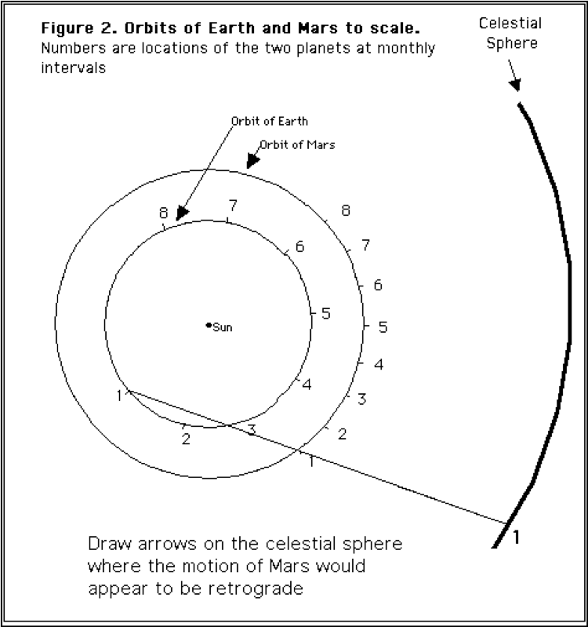
Figure 3
Background Stars

- When we look at Mars from Earth it looks like a bright ‘star’ against the background stars. Connect the dot locations of Earth 2 to Mars 2 by drawing a line between the dots into the celestial sphere-label as #2. Contine for position 3, 4 etc. For the first four months is Mars behind or in front of Earth? Does the motion of Mars appear direct or retrograde?

- Given that Earth is traveling faster, what happened on the 5th month? Does Mars now appear to move direct or retrograde?

- Is Mars actually moving forward or backward on its orbit? Explain why it appears to move backwards!

