Name:
Class:
Astronomy Beginnings

____ 1. Proposed that the sun was the center of the solar system because it was a simpler, purer model. Had no real evidence.  ____ 2. A philosopher that proposed geocentric theory model based on observations that Earth didn’t move and sun did. Did not test.  ____ 3. Great astronomer that took detailed records of precise planetary locations over many years….lost his nose in a duel!  ____ 4. Proposed epicycles (incorrectly) to account for observed retrograde motion of the planets.  ____ 5. Analyzed Mars data to correctly conclude the shape and speed of the planet orbits. Formed 3 laws.  ____ 6. First to seek out observational data to support conclusion of the sun centered model. Found that Jupiter has moons and therefore not all object revolve around the Earth. | A. Galileo  B. Aristotle  C. Kepler  D. Copernicus  E. Ptolomy  F. Brahe

Look at each model of the solar system below.
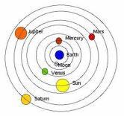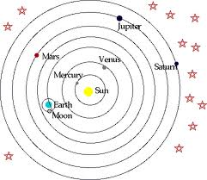

7. Name of Model: ___________________________  8. Person who  proposed the model: __________________________  9. Evidence for the  model: ____________________________ | 10. Name of Model: _____________________________  11. Person who  proposed the model: __________________________  12. Evidence for the  model: ____________________________

13. ________________________ the term Greeks gave to wandering ‘stars’.  14. ________________________ the study of the origin of the universe.  15. ________________________ the fake science where people use star positions to predict what will happen in their lives.  16. ________________________ the study of celestial objects and their formation, motion etc.  17. ________________________ the backwards movement of planets during their orbit (an optical illusion).  18. ________________________ the shape of planetary orbits in Kepler’s first law.  19. ________________________ the average distance between Earth and the sun.  20. _____________________ The amount of time it takes ANY planet to go around the sun once.  21. ________________________ the amount of ovalness of a planet orbit.  22. ________________________ the stone calendar in Europe that marked the position of the sun throughout the year.  23. ________________________ the circular loops of planets on their orbits as proposed by Ptolemy to explain retrograde motion.  24. ________________________ evidence seen by Galileo that proved Heliocentricity. | 1 Astronomical Unit (AU)  Astronomy  Astrology  Cosmology  Eccentricity  Epicycles  Ellipse  Period (yrs)  Planet  Retrograde motion  Stonehenge  Venus’ phases
A

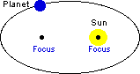
Use the letters from the diagram.
C
B
25. ___________ The focal point occupied by empty space.

26. ___________ The location where the planet experiences the most gravity.
D
Planet

27. ___________ The location where the planet travels the slowest.

28. ___________The focal point where there is a mass

