Name:
Class:
Scientific Method Review Sheet
- Science is defined as a process because__________________________________ and it is defined as knowledge because____________________________________________________________ .
- Fill in the table:
Type of Observation | Definition | Example
Qualitative |  | Brown car, small dog, Hot soup
 | Information gathered by measuring or counting an amount

- Fill in the table:
Measurement | Base Unit | Measurement tool
 |  | Ruler
 | Grams (g)
Volume

- Fill in the table:

Base Unit

- Complete the conversions:
A. 1 cm = _______________mm
B. 1 km = _______________ m E. 1 kL = ___________ L H. 56.98 cg = __________ mg
C. 1 m = ________________ mm F. 1 g = ____________ mg I. 34.56 cL = ____________ L
D. 345.2 mg = ____________ g G. 8.345 L = ________ cL J.0. 5698 km = __________ mm

- Write an observation and a matching inference about your backpack.

- Measure these lines with a ruler.

________ cm ________mm ________ cm _______mm ________ cm ________mm
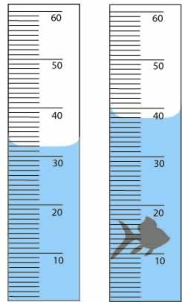
- What is the process being used to measure the volume of the objects?
_________________________________________
What is the volume of the… toy fish?
_________________

- Susan is studying honey production in bees. She measures the number of flowers visited by a colony of bees (a tough job!). Normally bees She observes the volume of honey produced in mL.
  - What is the question being tested?

  - What is the depending variable?

  - What is the independent variable?

  - What needs to be controlled (constant) in the study? List 4 things.

  - Indentify the control group.

  - Indentify the experimental groups.

  - What might be her hypothesis? (pay attention to format!)

  - Sketch a graph of the results.

- Fill in the following table with a check mark where it applies
 | Hypothesis | Theory
Has been tested
Has only initial data behind it
Has lots of data behind it
Can be proven false
Has so much data that it is accepted as true but is still tested
Can make predictions
Is the best current explanation of a large amount of data accepted by the scientific community

- Graph each of the following data sets on graph paper. Identify if it is a line or bar graph. Which is the independent and dependent data

Size of Magnet (cm) | Amount of metal paper clips picked up (g)
5 | 18
2 | 10
4 | 15
3 | 13
7 | 25

Country | # of Olympic Medals
USA | 66
Germany | 54
Russia | 40
South Africa | 36

