BIG PICTURE: CYCLING OF CARBON
YOU WILL DIE BUT THE CARBON WILL NOT; ITS CAREER DOES NOT END WITH YOU. IT WILL RETURN TO THE SOIL, AND THERE A PLANT MAY TAKE IT UP AGAIN IN TIME, SENDING IT ONCE MORE ON A CYCLE OF PLANT AND ANIMAL LIFE. – JACOB BRONOWSKI

Carbon is an element. It is part of oceans, air, rocks, soil and all living things. Carbon doesn’t stay in one place, it is always on the move. Carbon is an essential element of all living things on Earth, and the exchange of carbons through these living organisms is what is known as the fast carbon cycle. While elements within the slow carbon cycle take hundreds of millions of years, the movements within the fast carbon cycle happen within the lifetime of a particular organism. We hear a lot about the amount of carbon in our atmosphere increasing, but the actual number of carbon atoms on our planet has not changed since the Earth first formed - it's just that more carbon is spending more time as gas.
- Carbon moves from the atmosphere to plants. In the atmosphere, carbon is attached to oxygen in a gas called carbon dioxide (CO₂). With the help of the Sun, through the process of photosynthesis, carbon dioxide is pulled from the air to make plant food from carbon.
- Carbon moves from plants to animals. Through food chains, the carbon that is in plants moves to the animals that eat them. Animals that eat other animals get the carbon from their food too.
- Carbon moves from plants and animals to the ground. When plants and animals die, their bodies, wood and leaves decay bringing the carbon into the ground. Some become buried miles underground and will become fossil fuels in millions and millions of years.
- Carbon moves from living things to the atmosphere. Each time you exhale, you are releasing carbon dioxide gas (CO₂) into the atmosphere. Animals and plants get rid of carbon dioxide gas through a process called respiration.
- Carbon moves from fossil fuels to the atmosphere when fuels are burned. When humans burn fossil fuels to power factories, power plants, cars and trucks, most of the carbon quickly enters the atmosphere as carbon dioxide gas. Each year, five and a half billion tons of carbon is released by burning fossil fuels. That’s the weight of 100 million adult African elephants! Of the huge amount of carbon that is released from fuels, 3.3 billion tons enters the atmosphere and most of the rest becomes dissolved in seawater.
Written by: Roberta Johnson for National Earth Science Teachers Association on November 7, 2010

Create a model that shows the how carbon flows between plants, animals, soil and air:

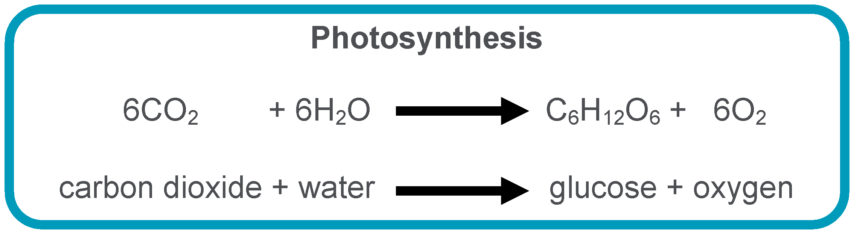
Let’s look at these processes in more detail. The twin systems of photosynthesis and respiration, and the movement of carbon in and out of the ocean are the main drivers of the natural "quick" carbon cycle. Considering the spectacular capacity of humans to pump CO2 out of fossil fuels and limestone, the biological contribution that we - and all other animals - make to the carbon cycle by eating, breathing and dying is pathetically small compared to what plants get up to. When plants photosynthesize, they absorb CO2 from the air, add water and make sugars and more plant out of it.
When plants or animals break that sugar back down for energy through cellular respiration (the opposite of photosynthesis) they release CO2 back into the atmosphere.
Written by: Bernie Hobbs for ABC Science on December 10, 2015
Using the information above and the given equation for photosynthesis, what could be a possible equation for cellular respiration?

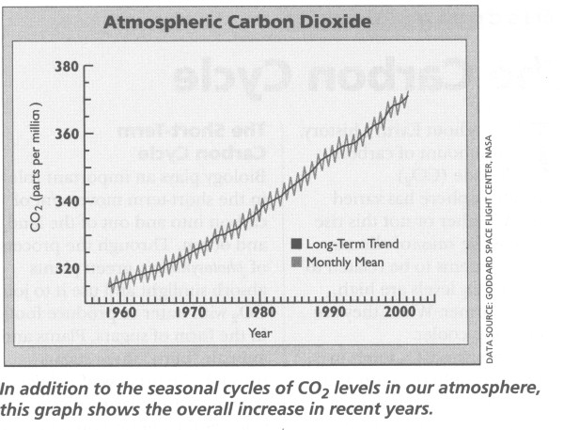
Photosynthesis occurs in plant leaves, so the level of atmospheric CO2 peaks every year during the northern spring (when plant growth and photosynthesis are at a max globally) and decreases during autumn (when leaves die and fall) as photosynthesis rates drop. In the graph to the right, you can see this process by noting the rise and drop of carbon levels each year (seasonal cycle). It's like watching the planet take its annual breath. I know. Plants are cool.
How Is The Carbon Cycle Changing? Carbon dioxide is a greenhouse gas and traps heat in the atmosphere. Without it and other greenhouse gases, Earth would be a frozen world. But humans have burned so much fuel that there is about 30% more carbon dioxide in the air today than there was about 150 years ago. The atmosphere has not held this much carbon for at least 420,000 years according to data from ice cores. More greenhouse gases such as carbon dioxide in our atmosphere are causing our planet to become warmer. The carbon cycle has always fluctuated and changed in response to major events such as changes to the climate. For example, when ice ages occurred in the past, the carbon cycle slowed down noticeably. When this happened, the coolness increased the growth of phytoplankton populations which added to the cooling effect on the earth. When the ice ages came to an end, the levels of carbon in the atmosphere rose drastically in response.
However, with the introduction of human industry, the carbon cycle is quickly becoming disturbed and its natural changes are being accelerated. The clearing of plants and the burning of fossil fuels releases more carbon into the atmosphere that should typically be released slowly, while not leaving behind the plants to absorb it. Throughout Earth's history, the amount of carbon dioxide (CO₂) in the atmosphere has varied greatly. Whether or not this rise and fall is the cause of climate change, it seems to be related to it. When CO₂ levels are high, the Earth is warmer. When they are low, the Earth is cooler.
Written by: Roberta Johnson for National Earth Science Teachers Association on November 7, 2010

Analysis Questions:
1. Explain the meaning of the quote by Jacob Bronowski at the top of this article:

2. What is the relationship between cellular respiration and photosynthesis?

3. Why does the amount of carbon in the air fluctuate (go up/down) seasonally? (Refer to graph)

4. What is the relationship between carbon in the atmosphere and climate change?

5. List three ways in which humans are adding increasing the amount of carbon in the atmosphere (see last paragraph).

6. Some scientists are proposing planting more trees as a solution to lowering CO2 levels in the air. Would this work? Explain.

BIG PICTURE: CYCLING OF CARBON KEY
YOU WILL DIE BUT THE CARBON WILL NOT; ITS CAREER DOES NOT END WITH YOU. IT WILL RETURN TO THE SOIL, AND THERE A PLANT MAY TAKE IT UP AGAIN IN TIME, SENDING IT ONCE MORE ON A CYCLE OF PLANT AND ANIMAL LIFE. – JACOB BRONOWSKI

Carbon is an element. It is part of oceans, air, rocks, soil and all living things. Carbon doesn’t stay in one place, it is always on the move. Carbon is an essential element of all living things on Earth, and the exchange of carbons through these living organisms is what is known as the fast carbon cycle. While elements within the slow carbon cycle take hundreds of millions of years, the movements within the fast carbon cycle happen within the lifetime of a particular organism. We hear a lot about the amount of carbon in our atmosphere increasing, but the actual number of carbon atoms on our planet has not changed since the Earth first formed - it's just that more carbon is spending more time as gas.
- Carbon moves from the atmosphere to plants. In the atmosphere, carbon is attached to oxygen in a gas called carbon dioxide (CO₂). With the help of the Sun, through the process of photosynthesis, carbon dioxide is pulled from the air to make plant food from carbon.
- Carbon moves from plants to animals. Through food chains, the carbon that is in plants moves to the animals that eat them. Animals that eat other animals get the carbon from their food too.
- Carbon moves from plants and animals to the ground. When plants and animals die, their bodies, wood and leaves decay bringing the carbon into the ground. Some become buried miles underground and will become fossil fuels in millions and millions of years.
- Carbon moves from living things to the atmosphere. Each time you exhale, you are releasing carbon dioxide gas (CO₂) into the atmosphere. Animals and plants get rid of carbon dioxide gas through a process called respiration.
- Carbon moves from fossil fuels to the atmosphere when fuels are burned. When humans burn fossil fuels to power factories, power plants, cars and trucks, most of the carbon quickly enters the atmosphere as carbon dioxide gas. Each year, five and a half billion tons of carbon is released by burning fossil fuels. That’s the weight of 100 million adult African elephants! Of the huge amount of carbon that is released from fuels, 3.3 billion tons enters the atmosphere and most of the rest becomes dissolved in seawater.
Written by: Roberta Johnson for National Earth Science Teachers Association on November 7, 2010

Create a model that shows the how carbon flows between plants, animals, soil and air:
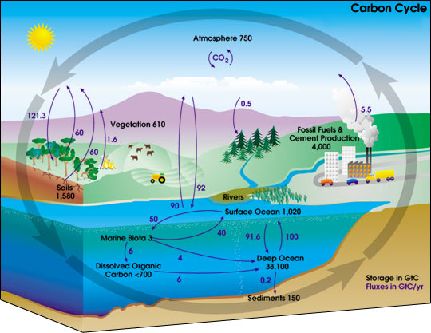
Student Answers Will Vary

Let’s look at these processes in more detail. The twin systems of photosynthesis and respiration, and the movement of carbon in and out of the ocean are the main drivers of the natural "quick" carbon cycle. Considering the spectacular capacity of humans to pump CO2 out of fossil fuels and limestone, the biological contribution that we - and all other animals - make to the carbon cycle by eating, breathing and dying is pathetically small compared to what plants get up to. When plants photosynthesise, they suck CO2 from the air, add water and make sugars and more plant out of it.
When plants or animals break that sugar back down for energy through cellular respiration (the opposite of photosynthesis) they release CO2 back into the atmosphere. Written by: Bernie Hobbs for ABC Science on December 10, 2015
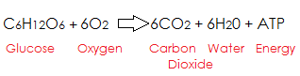
Using the information above and the given equation for cellular respiration, what could be a possible equation for photosynthesis?

Photosynthesis occurs in plant leaves, so the level of atmospheric CO2 peaks every year during the northern spring (when plant growth and photosynthesis are at a max globally) and decreases during autumn (when leaves die and fall) as photosynthesis rates drop. In the graph to the right, you can see this process by noting the rise and drop of carbon levels each year (seasonal cycle). It's like watching the planet take its annual breath. I know. Plants are cool.
How Is The Carbon Cycle Changing? Carbon dioxide is a greenhouse gas and traps heat in the atmosphere. Without it and other greenhouse gases, Earth would be a frozen world. But humans have burned so much fuel that there is about 30% more carbon dioxide in the air today than there was about 150 years ago. The atmosphere has not held this much carbon for at least 420,000 years according to data from ice cores. More greenhouse gases such as carbon dioxide in our atmosphere are causing our planet to become warmer. The carbon cycle has always fluctuated and changed in response to major events such as changes to the climate. For example, when ice ages occurred in the past, the carbon cycle slowed down noticeably. When this happened, the coolness increased the growth of phytoplankton populations which added to the cooling effect on the earth. When the ice ages came to an end, the levels of carbon in the atmosphere rose drastically in response.
However, with the introduction of human industry, the carbon cycle is quickly becoming disturbed and its natural changes are being accelerated. The clearing of plants and the burning of fossil fuels releases more carbon into the atmosphere that should typically be released slowly, while not leaving behind the plants to absorb it. Throughout Earth's history, the amount of carbon dioxide (CO₂) in the atmosphere has varied greatly. Whether or not this rise and fall is the cause of climate change, it seems to be related to it. When CO₂ levels are high, the Earth is warmer. When they are low, the Earth is cooler.
Written by: Roberta Johnson for National Earth Science Teachers Association on November 7, 2010

Analysis Questions:
1. Explain the meaning of the quote at the top of this article:
The quote is referring to the cycling of all matter on Earth. The carbon atoms that make up you are transferred to the soil and beyond when you die.

2. What is the relationship between respiration and photosynthesis?
They are opposite cellular processes. Photosynthesis takes carbon out of the air and stores it as glucose in plant bodies. Cellular respiration breaks down glucose and releases it back into the air.

3. Why does the amount of carbon in the air fluctuate seasonally? (Refer to graph)
Because plants take carbon out of the air and store it in their bodies. During winter, leaves fall off trees and plants go dormant (more or less), so the amount of carbon being pulled from the air is less in the winter and increases in the summer.

4. What is the relationship between carbon in the atmosphere and climate change?
There is a direct correlation between atmospheric carbon and a rise in temperature.

5. List three ways in which humans are adding more carbon into the atmosphere than before (see last paragraph).
Clearing forests, driving cars, industry

6. Some scientists are proposing planting more trees as a solution to lowering CO2 levels in the air. Explain how this would work.
Planting more trees would pull more carbon out of the air. During photosynthesis, plants pull carbon out of the air and store it in their bodies.

