Mercury in the Environment

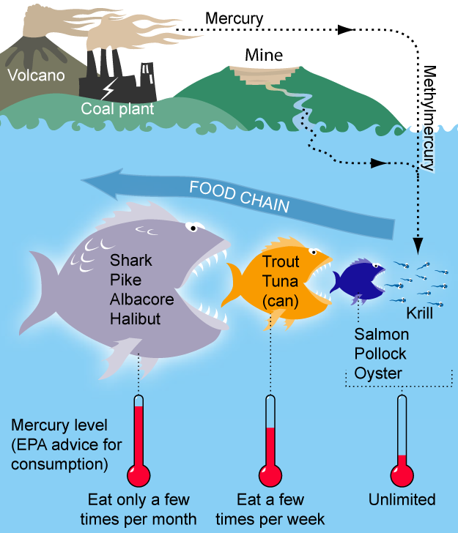
Mercury is among a group of pollutants that "persist" in the environment, meaning that they do not break down or go away. Mercury cannot be destroyed, it cannot be combusted, and it does not degrade. Mercury also "biomagnifies,” meaning it builds up in the food chain over time.
Figure 1: A basic ocean food chain showing biomagnification of mercury. Image (CC BY 3.0) Bretwood Higman, Ground Truth Trekking.
Mercury can be released in the environment from natural sources, such as volcanic and geothermal activity, marine environments or forest fires, or it can be released from anthropogenic (man-made) sources like coal-fired power plants and other industrial activities. Recent studies suggest that human activity contributes 50-70% of the mercury in the environment globally (EPA Office of Air Quality and Standards Report to Congress, 1997). Once mercury enters the environment, it circulates in and out of the atmosphere until it ends up in the bottoms of lakes and oceans. Because mercury persists for so long, it can be very difficult to identify where the mercury first entered the environment.

Biomagnification of Mercury
When mercury falls in rain or snow, it may eventually be washed into lakes, oceans, rivers, and groundwater supplies. Bacteria in soils and sediments convert mercury to methylmercury. In this form, it is taken up by tiny aquatic plants and animals. Fish that eat these organisms accumulate methylmercury in their bodies. As bigger fish eat smaller ones, the methylmercury is concentrated further up the food chain through a process known as biomagnification.
Methylmercury concentrations in fish depend on many factors, including: the concentration of methylmercury in the water, water pH and temperature, and what organisms live in the water. Methylmercury concentrations in fish may also be affected by the presence of sulfur and other chemicals in the water. Because of these variables, and because food webs are very complex, biomagnification is hard to predict and can vary from one water body to another.
However, in a given water body, the highest concentrations of methylmercury are generally found in large fish that eat other fish. The concentrations of methylmercury in large fish can be over a million-times larger than in the surrounding water. Mercury is tightly bound to proteins in all fish tissue, including muscle. There is no method of cooking or cleaning fish that will reduce the amount of mercury in a meal.

Reading adapted from: Utah Department of Environmental Quality. (n.d.) Mercury in the environment. Retrieved from http://www.mercury.utah.gov/bioaccumulation.htm
“Mercury Food Chain” image retrieved from https://en.wikipedia.org/wiki/File:MercuryFoodChain-01.png/
Reflect and Review:
- What are some characteristics of mercury that make it such a serious environmental pollutant?

- Why can it be difficult to identify the source of mercury pollution?

- If methylmercury in fish can’t be removed by cooking or cleaning, what are some characteristics of fish you could pick at the grocery store to minimize your exposure?

